ICMA 2.0

**Table of contents**

Introduction 3

Workspaces 3

Loading data 3

Analysing Images and Creating Models 4

Disclaimer 10

**Introduction**

The Integrated Cardiac Modelling and Analysis Module (henceforth referred to as ICMA), is a subject specific cardiac-ultrasound image based analysis and finite-element-model building software. The software is aimed to help perform strain analysis. It also enables them to compare the subject’s cardiac geometry with a population or with that of the subject over time.

**Workspaces**

Workspaces provide a convenient cache location to store preferences, past choices for directories, images etc. They are designed to reduce downloads from PACS, as studies are static and do not change. Consequently, US images are stored in the cache when accessed from a PACS. However, the number of images is limited by the cache size. Users can alter and clear the space through the preferences.

A Fanout cache is created at the workspace location.

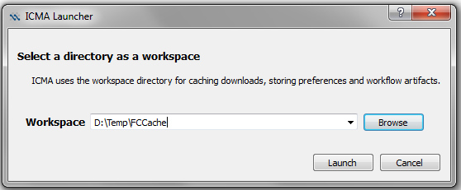

**Loading data**

DICOM data can be accessed from PACS, however, PACS needs to support WADO (Web Access of Dicom Objects) protocol. Opensource PACS like DCM4CHEE provide this. If your target PACS does not provide this, you may have to develop an interface or use DCM4CHEE as an intermediary.

Locally stored DICOM files can also be accessed either through the DICOMDIR file or by directly pointing to the directory. In the latter case, all the directories are recursively parsed and DICOM studies are loaded.

The data is organized per patient.

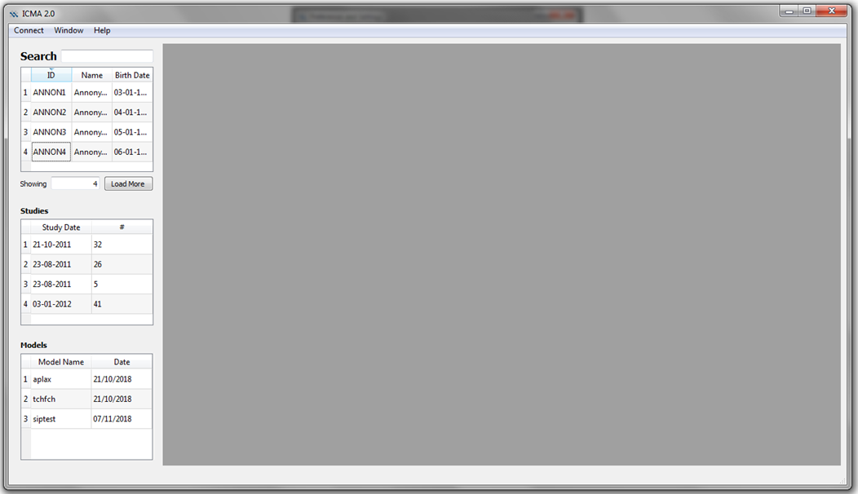

Double clicking on the patient name will list all the study instances associated with the patient. Also any models associated with the patient is also listed.

**Analysing Images and Creating Models**

DICOM cine images associated with the study are loaded in a tabbed window.

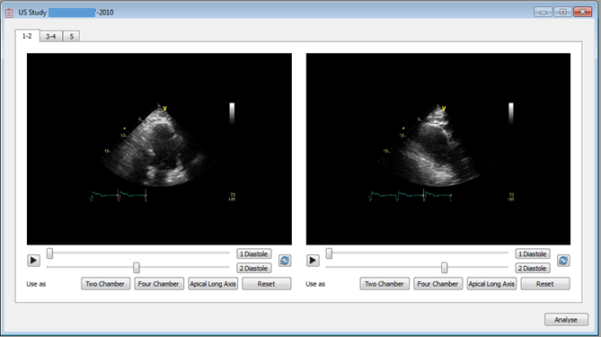

The number of images per tab and number of rows are configurable through the Preferences window.

Setting up for speckle tracking

Images for Speckle tracking should be selected through this window. Users are expected to select the Long Axis view associated with the image and the start and end of a cardiac cycle.

The start and end distole can be selected by moving the sliders. To lock in a selection, the Diastole button needs to be clicked. The reset icon next to these button can be used to return to the tool selected values.

The long axis view can be specified by clicking the Chamber buttons.

When a view is assigned, the background changed to red.

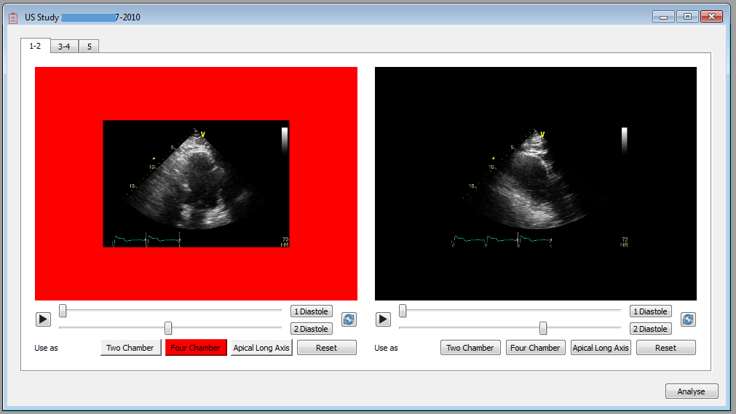

Only one image can be assigned to a view at a time. If an another image is selected for the view, the previous one is released.

View specification can be released by the 'Reset' button.

One or more (up to three) views can be selected for speckle tracking and model fitting.

After providing the cardiac cycle, view details. The process can be started using the Analyse button.

Speckle Tracking

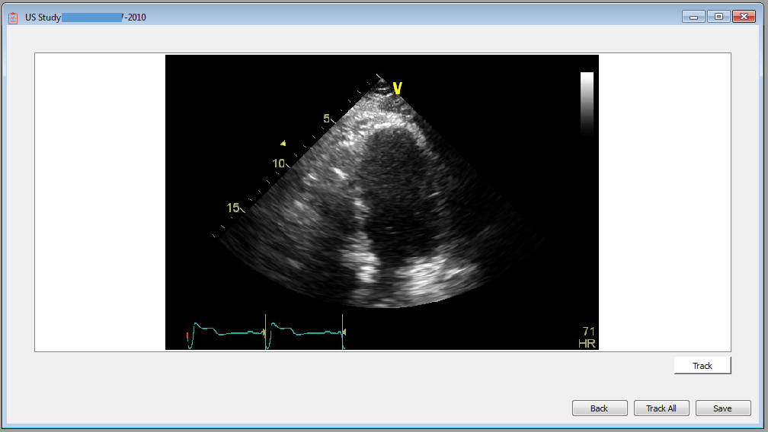

For each selected view a tracker column is created. Landmarks can be created by clicking on the images.

The first frame corresponds to the start End Diastole image. You are required to provide the base plane and Apex locations by clicking. The view allows for three points to be created

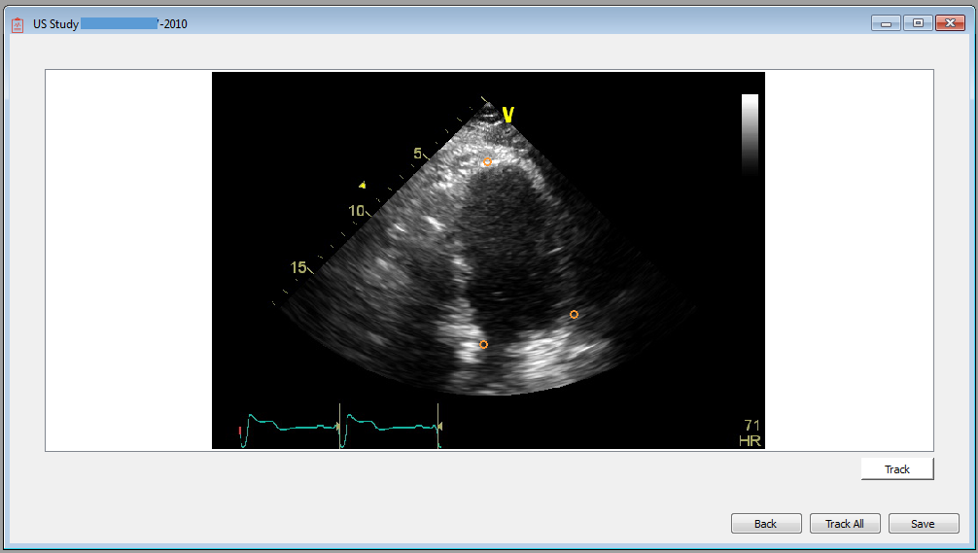

The clicking order does not matter. Once the three landmarks are provided, a boundary spline is created as

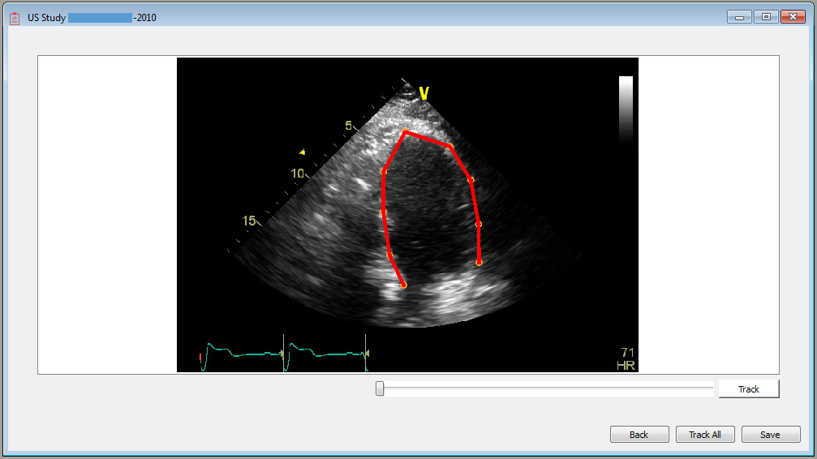

Additional landmarks are also provided. User can move this points to capture the boundary as desired. The boundary profile is used to create and track speckles, so the boundary affects the final results.

Following this the baseplane location for the end systole frame should be provide. This frame can be reached by moving the slider, and clicking two landmarks to identify the baseplane location, as

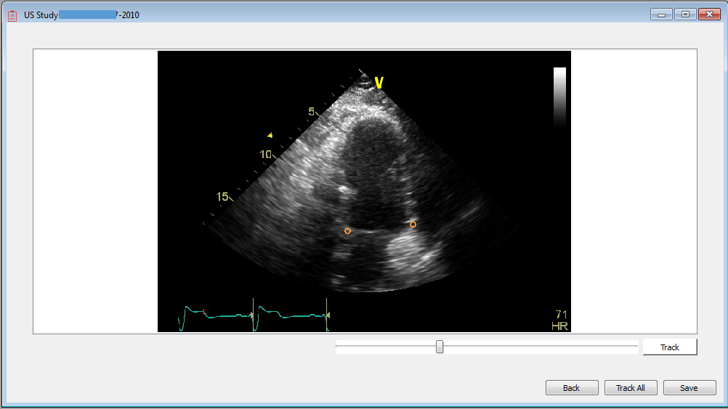

Speckle tracking can then be performed individually (by clicking the Track button) or for all views (Track All) button.

Speckle tracking uses many parameters that can be configured via Preferences.

These parameters include number of frames to be tracked, the number of speckles to be used, inter timeframe smoothing coefficient and weightage for model predicted vs tracked results.

Once, tracking is completed. the boundary kinematics and the strain values are plotted, like

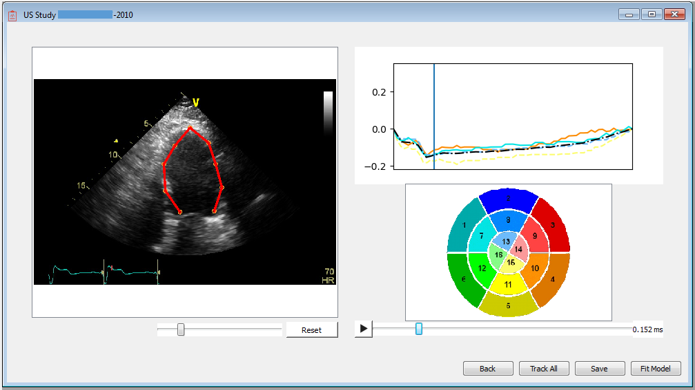

The play button can be used to view the boundary spline motion. The boundary for each frame can be investigated by moving the time slider. The boundaries can be manually modified per frame if necessary.

Reset will discard the speckle tracking results and return to the initial state where the landmarks need to be specified.

The speckle tracking results which include the location of the landmarks per frame, per view, strain values and details regarding the DICOM image can be saved to disk as a xlsx file using the Save button.

A finite element model capturing the chamber geometry based on the tracked boundary can be created using the Fit Model button. The resulting model is as

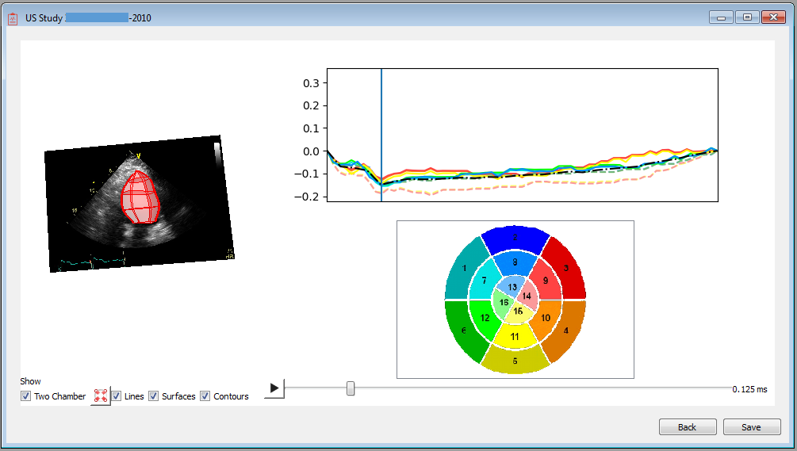

There is a 3D view on the left, where the mesh and the images are rendered. Check boxes to show and hide the available view are provided. The view can be recentered to the original configuration using the compress button.

Different graphics like lines, surfaces and the contours of intersection between the mesh and an image plane can also be shown and hidden. The bullseye view can be used to select (by clicking on the coloured area with the strain number) the strain values that are rendered.

Models can also be saved using the save button. Note that the parent directory where the model files should be stored needs to be provided, for instance

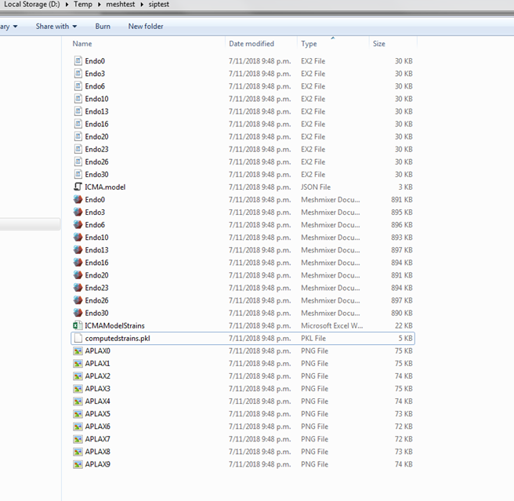

The project named siptest is created under the parent directory D:\Temp\meshtest

The folder contains the images associated with the model, opencmiss-zinc format model files, stl files for each geometric configuration within the cycle and the strain values in the form of xlsx file. The json and pkl files are required to reload the model in the tool.

The preferences can be altered using

Windows->Preferences Action

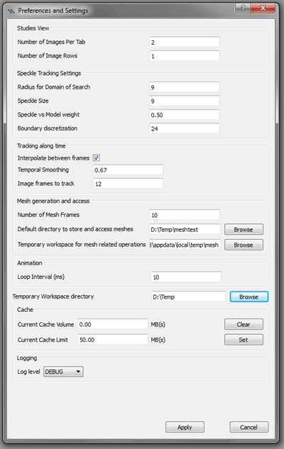

Log of the events are output and can be used for debugging and analysis purposes.

**Disclaimer**

*Medical advice disclaimer*

*The Software, information, content, models and/or data (collectively, "Information") contained therein are for informational purposes only. The Software does not provide any medical advice, and the Information should not be so construed or used. Using patient data and/or providing personal or medical information does not create a physician-patient relationship between you and the Author(s). Nothing contained in the Software is intended to create a physician-patient relationship, to replace the services of a licensed, trained physician or health professional or to be a substitute for medical advice of a physician or trained health professional licensed in your jurisdiction. You should not rely on anything produced by the Software, and you should consult a physician licensed in your jurisdiction in all matters relating to your health. You hereby agree that you shall not make any health or medical related decision, offer medical advice based in whole or in part on anything produced by this software.*

*Warranty disclaimer*

*THE SOFTWARE IS PROVIDED "AS IS", WITHOUT WARRANTY OF ANY KIND, EXPRESS OR IMPLIED, INCLUDING BUT NOT LIMITED TO THE WARRANTIES OF MERCHANTABILITY, FITNESS FOR A PARTICULAR PURPOSE AND NONINFRINGEMENT. IN NO EVENT SHALL THE AUTHORS OR COPYRIGHT HOLDERS BE LIABLE FOR ANY CLAIM, DAMAGES OR OTHER LIABILITY, WHETHER IN AN ACTION OF CONTRACT, TORT OR OTHERWISE, ARISING FROM, OUT OF OR IN CONNECTION WITH THE SOFTWARE OR THE USE OR OTHER DEALINGS IN THE SOFTWARE.*